BSM AY 2016-2017 Assessment
Phase 1: Assessment Plan
Learning Outcome assessed:
Learning Outcome 09) Technology
Students will describe the intertwined relationship among technology, information, and the organizational structure and operations in order to assess and evaluate the core technology concepts that enable sound organizational decision making.

Assessment Method:
Assignment agreed upon by all faculty before the semester:
Walmart vs. Amazon (case attached)
Targeted performance, based on rubrics:
80% of students meet or exceed expectations
Evaluation Process:
Students wrote an essay analyzing a business case study through the lens of system theory. First, students identified and explained social, technical, and knowledge systems and their components in a business case study. Next, they explained and discussed the relationships and interactions of the three systems evident in the case study. Essays were evaluated based on three criteria of below expectation, meeting expectation, and exceeding expectation. Instructor of the course evaluated each individual essay as exceeding expectation if students clearly identified the three systems and their components and clearly explained their relationships, meeting expectation if students identified the three systems and their components but briefly explained the relationships, and below expectation if students identified the three systems and their components but did not explain the relationships of the systems. Details of the evaluations are provided in the rubric.
Rubric: (see results)
Course where learning outcome was assessed:
BSM 303-57 – Systems & Technology
Evaluator(s):
Steve Morris
Phase 2: Results Assessment and Planned Action
Results:
After assessing the students’ work on the case Walmart vs Amazon (using the above rubric), 12 of 13 students fell below the 80% level of achievement. It is believed that having the case done early in the course hindered achievement as the students were not aware of case writing expectations, nor were they fully aware of the grading rubric (though it had been provided).
Case Study: Who’s the World’s Top Retailer? Walmart and Amazon Duke it out
1) Analyze Walmart and Amazon.com using the competitive forces and value chain models.
2) Compare Walmart and Amazon’s business models and business strategies.
3) What role does information technology play in each of these businesses? How is it helping them refine their business strategies?
4) Will Walmart be successful against Amazon.com? Explain your answer.
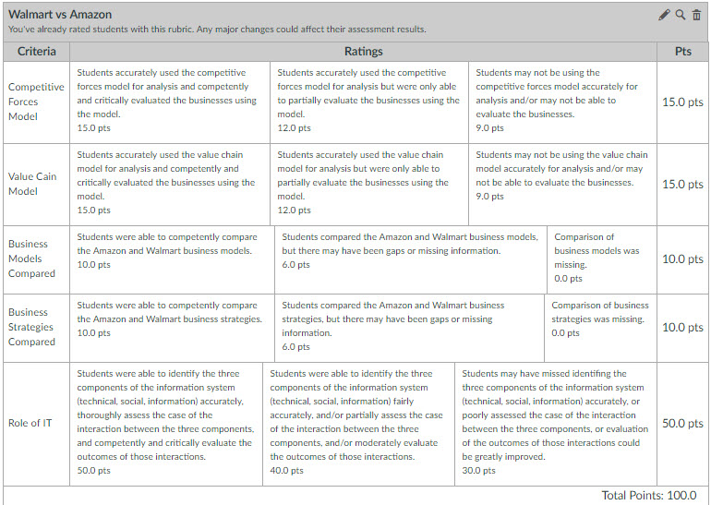
Suggested Action:
Improvements to be made in the Spring ’17 course is to introduce case writing expectations earlier in the course; provide examples of good case writing; go over the rubric in more detail. These changes are expected to improve student learning outcomes in the ensuing semester which will help to close the loop on the learning outcome. LO 09 – Technology will be assessed again at the end of the Spring 2017 semester.

Phase 3: Closing the Loop

In the year that the assessment is made, this is good place to describe how the suggested actions might be evaluated in a future assessment cycle. When that cycle is complete, the results can be added to this document to finalize the report.

